Process to install GIT and import projects into Eclipse.

1) Install GIT <https://git-scm.com/download/win>

Select all the defaults within the install process.Select all the defaults within the install process..

2) Add new windows environment variablesvariable:

%GIT_HOME%\bin

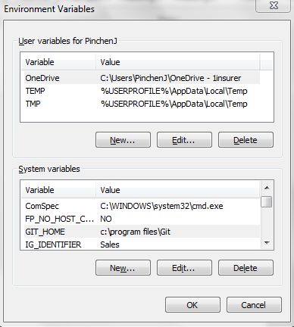

Add Git to the path variable

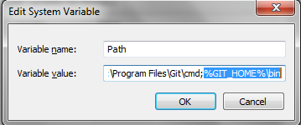

3 Start GIT Bash as an ADMINISTRATOR

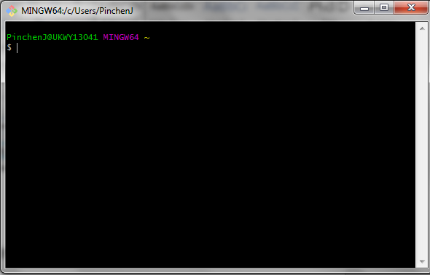

Enter this command in to generate the ssh key.

ssh-keygen -t rsa

press return.

4) Open up the ssh.pud key location using notepad

C:\users\”PXXXX”\.ssh

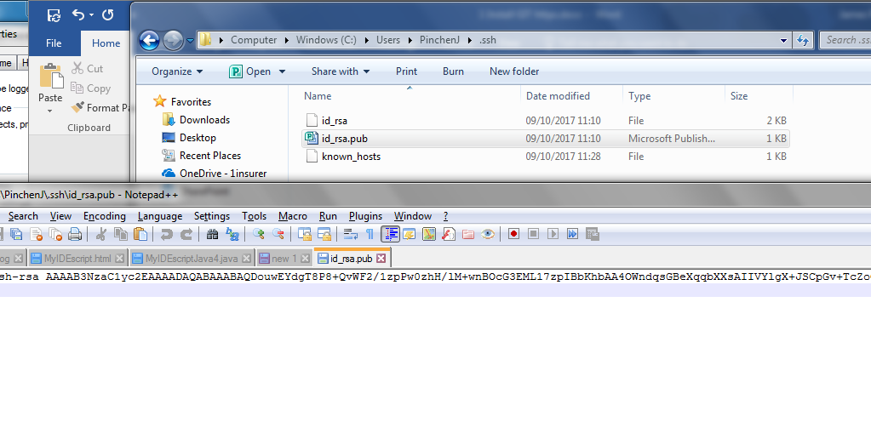

Load up Git Hub and enter in your key.

5) Load up Git Hub and enter in your key.

The option is found by editing your user and is on the left-hand side.

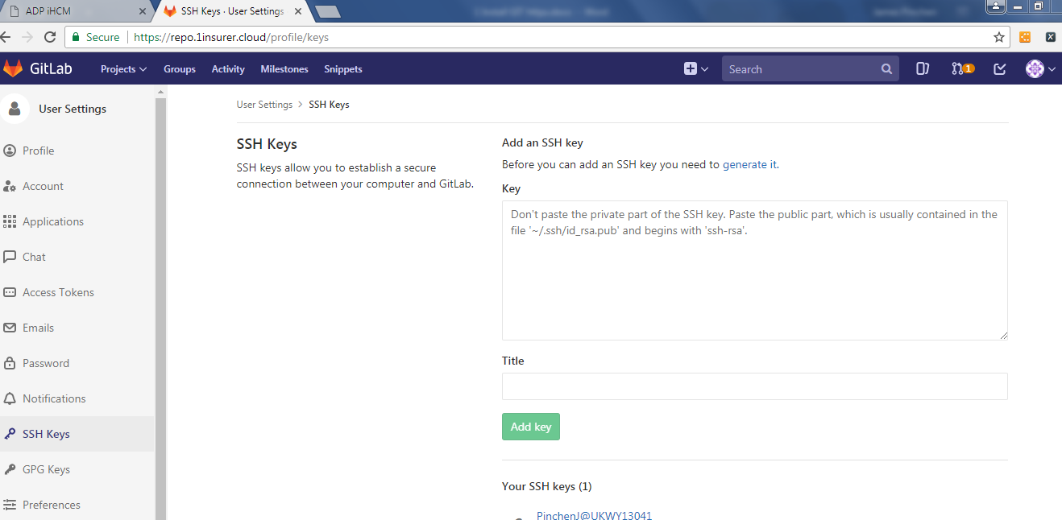

6) Create a temp git folder within your windows temp folder. This is to make the import process work better.

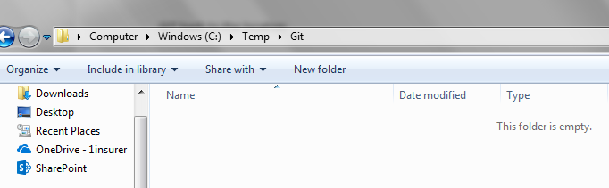

7) GIT bash to the temp location.

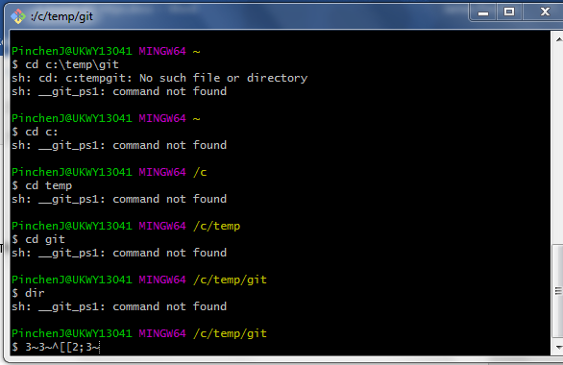

Run the command:

$ git clone [git@repo.1insurer.cloud:1insurer-test-framework/TestFramework.git](mailto:git@repo.1insurer.cloud:1insurer-test-framework/TestFramework.git)

Type YES

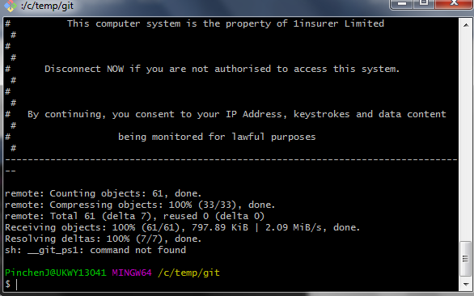

8) Open Eclipse

File\Import\

Select GIT

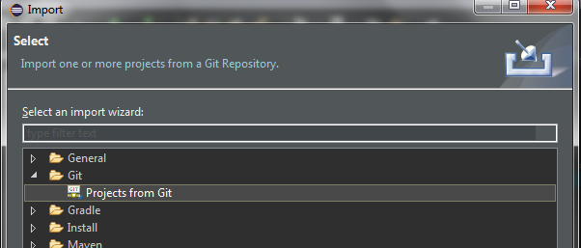

Click Next

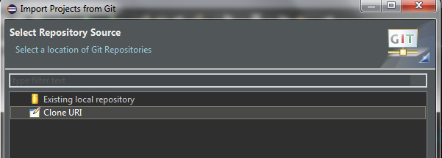  
Click next

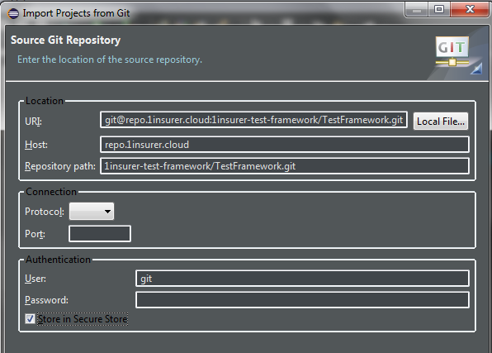

Click next

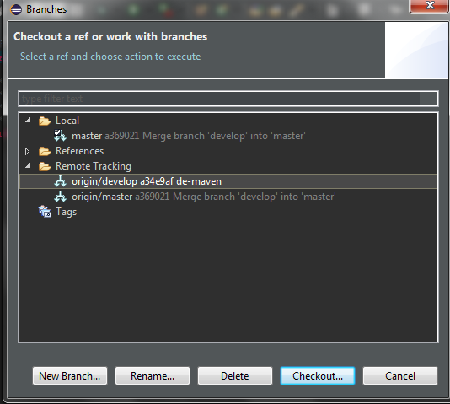

Checkout new local dev branch.

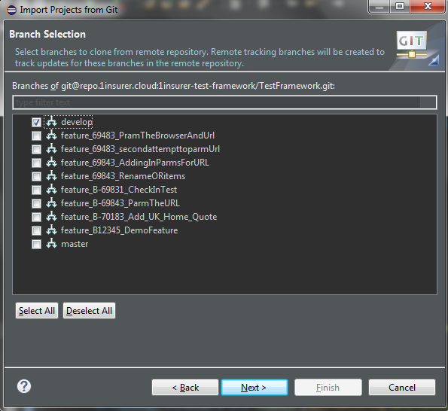

Create feature locally from the Develop branch.